1. **Write a program to validate Mobile Number length using user define exception (input in int type only)**

class MobileNoError(Exception):

pass

def isValidMobileNo(num):

if len(str(num))!=10:

raise MobileNoError('Your Mobile number is Invalid. ')

try:

mno=int(input('Enter your Mobile Number='))

isValidMobileNo(mno)

except MobileNoError as e:

print("Error:-",e)

else:

print('Your Mobile Number:-',mno)

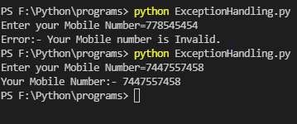

1. **Write a program to explain else statement proper comments with notes**

a=int(input('Enter a Number1='))

b=int(input('Enter a Number2='))

try:

div=a/b

print('Try block completed.')

except ZeroDivisionError as e:

print('Error is Occured in program.')

print('Error:-.',e)

# it is used to define a statement which we want to execute without exception.

else:

print('In program,Exception is not Raised.')

print('Division',div)

print('Program completed')

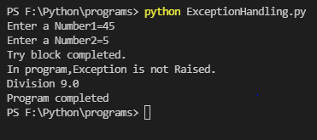

1. **Write a program to explain raise keyword proper comments with notes.**

try:

a=int(input('Enter a Number1='))

b=int(input('Enter a Number2='))

if b==0:

# raise keyword is used to raised exception manually.

raise ZeroDivisionError('Number2 should not be 0')

div=a/b

except ZeroDivisionError as e:

print("Error:-",e)

else:

print("Division=",div)

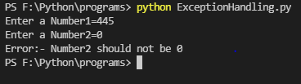

1. **Write a program to multiple except in one try with proper comments and notes.**

try:

a=int(input('Enter a Number1='))

b=int(input('Enter a Number2='))

div=a/b

print('Try block completed.')

# It is used to handle some exception with common set of code.

except(ZeroDivisionError,ValueError) as e:

print('Error is occured in program.')

print("Error:-",e)

print('!!!...PLEASE ENTER VALID INPUTS...!!!')

except Exception as e:

print('Error is occured in program.')

print("Error:-",e)

else:

print('In program,Exception is not Raised.')

print('Division:',div)

print('Program completed')

